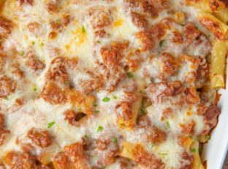
Baked Ziti
Prep Time 25 minutes Cook Time 30 minutes
12 Servings

Ingredients
1 lb dry ziti pasta
1 chopped yellow onion
1 lb Italian Sausage
6 cups Marinara Sauce
1½ cups sour cream
1½ cups shredded mozzarella cheese
8 slices provolone cheese
¼ cup shredded Parmesan cheese
2 cloves of garlic (optional)
Directions
- Cook pasta one minute shy of the directions and drain, add a little sauce to coat pasta.
- Cook sausage and onions in a large frying pan with cover until meat is fully cooked on medium high.
- Add in marinara sauce and let simmer for 20 minutes on medium heat, then add garlic.
- Preheat oven to 350 degrees.
- Layer in 9x13 baking dish in order
- half the pasta
- half the meat sauce
- all the sour cream (1½ cups)
- 1/2 (3/4 cup) the mozzarella
- all of the provolone cheese (8 slices)
- the rest of the pasta
- the rest of the meat sauce
- the rest of the mozzarella (3/4 cup)
- all of the Parmesan cheese (¼ cup)
- Bake uncovered, on a baking sheet, for 30 minutes (22 ½ minutes convection oven) until golden brown and bubbly.
Notes
Pasta does not get soggy when made and frozen.

